MACH4METAL

Metalworking machinery
Transito 21,
6909 DA BABBERICH
Netherlands
Tel. +31 (0)316 – 247123
Fax. +31 (0)316 - 247956

Account No: 66.52.13.883
IBAN : NL33 INGB 0665 2138 83
BIC : INGBNL2A

MAZAK NEXUS 510C-II VMC
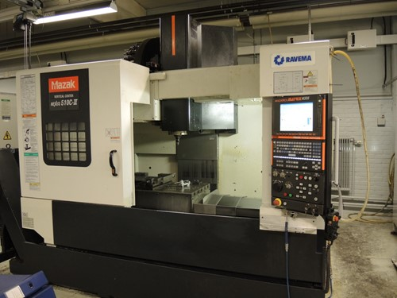
- Make : MAZAK Japan
- Type : NEXUS 510C-II
- YOP : 2007
- Serial :

- X Travel : 1.050
- Y Travel : 510
- Z Travel : 510

- Table length : 1.300
- Table width : 550
- Table load : 1.200
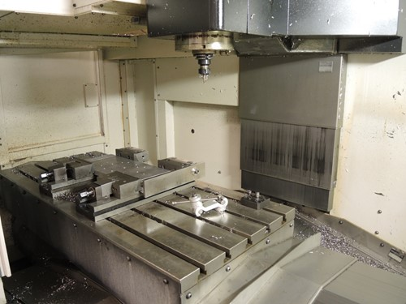
- Column – spindle : 576

- Spindle : Sk 40
- Spindle speed : 12.000
- Spindle power : 18.5 kW

- MAZATROL MATRIX NEXUS
- ATC with 30 positions
- Tool Ø 80 x 350 x 8 Kg

- Feed rate X/Y/Z : 8.000 mm/M
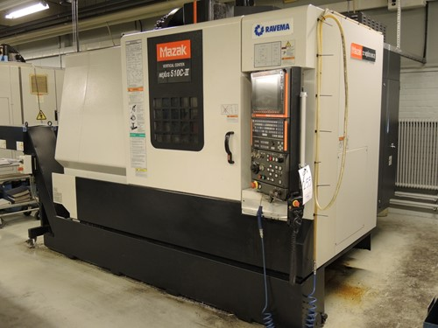
- Rapid rate : 36.000 mm/M

- Dimensions
- Length : 2.880
- Width : 2.835
- Height : 2.810
- Weight : 6.900

Please Note: The above information has been obtained to the best of our ability and belief from, and from the manufacturers where possible. It is given in good faith, but its accuracy can not be guaranteed. Accordingly, it will not form a representation or constitute contractual terms. We advise you to check any vital details!

